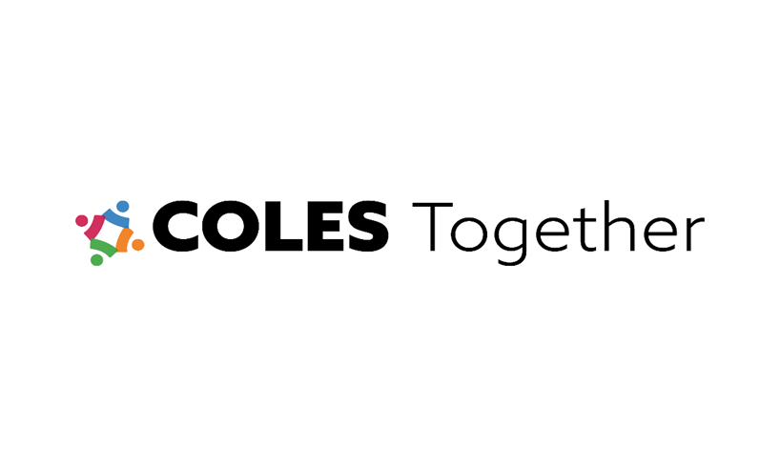

Five-Year Coles County Regional Strategic Economic Development Plan

August 1, 2024

Written by

Dr. Ronda Sauget, MBA

President & CEO

Coles Together Economic Development Organization (EDO)

**Overview**

Coles Together is a 501c6 non-profit Economic Development Organization (EDO) representing a unified voice for Coles County, Illinois. The mission of Coles Together is to proactively market and develop communications activities to promote the competitive advantages and resources of Coles County, thus enabling a thriving, diverse, innovative, healthy, and growing ecosystem for all business sectors and enhancing community engagement, empowering citizens, and driving a high quality of life. By working together, employers bring sustainable job creation, business expansion, and longevity needed for a flourishing community. The Coles Together team assists with new business attraction, retention, and expansion of firm and industry sectors while working with the local community on workforce retention, recruitment, training, and skills advancement needed by area employers.

Coles County, Illinois, is a tertiary marketplace with two micro-cities, Charleston and Mattoon, and provides a perfect blend of rural agri-business communities, such as Oakland and Ashmore, consisting of approximately 46,185 residents with over 848,199 residents located within 60 miles. Coles County has multiple thriving economic power zones, including:

* Healthcare Hub Network System (SBL Healthcare Complex, Carle, SIHF, HSHS St. Anthony’s Medical, Regional Headquarters of Blue Cross Blue Shield, etc.)
* Educational Centers of Excellence (Eastern Illinois University, Lakeland College, Lift/Mattoon School System, Trojan A&M Center/Charleston School System, Oakland School System/Agri-Business Programs, etc.)
* Manufacturing, Business, Agri-Business, Food/Petcare, and Food Processing Industrial Sectors (Mars Petcare, John Deere Logistics Center, Justrite, Vesuvius, Hi-Cone, Grupo Bimbo, Kingspan, and many more)
* Thriving Retail Headquarters (Rural King 146 stores, logistics centers, 9,000 employees) and growing regional retail and food restaurants sector
* Regional Sports Complex (Emerald Acres Sports and Charleston Sports Complex), EIU Collegiate and University-Level Competitive Sports D1 Level, etc.
* Multi-Modal Transportation Supply Chain Logistics (rail – CN, Eastern Illinois Railroad), road (I-57, Rt 16, Rt 130, & Rt 45), and Air – Coles County Airport (with through-the-fence business operations)
* Recreation, History, Entertainment, and Tourism Attractions (Lincoln Living History Sites, Mattoon/Charleston/Paradise Lakes, Family Friendly Parks, AMC Theaters, and so much more)

The above economic power zones draw thousands of residents to Coles County daily for healthcare, shopping, sustainable jobs, dining, family sports, recreation, attractions, and many other activities. Coles County is quickly becoming the place for economic development at all levels, creating a strong and healthy ecosystem with a strong need for housing and childcare to sustain this system.

**History**

The Coles County Economic Development Council was founded on August 30, 1988, by prominent business, community, and governmental leaders who desire to build a stronger economy in Coles County, Illinois. This distinguished group of business leaders was led by Richard Lumpkin, serving as its first president; Robert Moore, its first vice president; Max Cougill, its first treasurer; Roy Carr, its first secretary; and other governmental, business, and community leaders. On February 6th, 1990, the group officially changed its name to Coles Together to bring everyone in Coles County together for a common purpose: to promote the improvement, diversification, and growth of the economic base of the Coles County regional area. This work was designed for existing and new commerce and industry to assist and retain existing businesses, preserve employment opportunities, attract new firms, and create sustainable employment.

Coles Together was designed as the county-wide marketing agency for Coles County with the following purpose:

* Bringing community leaders together to support the formation of a county-wide marketing agency in Coles County.
* Coles Together would have more “clout” with the Illinois agencies and other organizations as a unified voice.
* A county-wide marketing agency would create greater prospective interest.
* Enable Coles County communities to work together for projects and not compete head-to-head for projects and
* A county-wide marketing agency allows for greater efficiency in the utilization of resources.

The desire was to proactively move Coles County forward, generating a more substantial tax base, robust business climate, strong job creation, and enhanced quality of life for all residents, thus creating a wonderful community to raise children with values, morals, integrity, and leadership characteristics gained from a hard-working agriculturally based business community upbringing.

**Mission**

Coles Together provides economic development activities for new business attraction and existing business expansion/retention. Coles Together proactively promotes the area through marketing and communications efforts to build positive awareness of new investment and job creation activities. Coles Together administers Enterprise Zone benefits for Coles County, including property tax abatement (commercial projects 3-year declining abatements 100%-75%-50% and Industrial project abatement 100% for 10 years on-site improvements), building materials sales tax exemption certificates, and waive building permits for industrial projects; and also helps administer the Community Development Corporation (CDC) gap funding at a blended rate for specific qualified projects.

**Vision**

Coles Together's vision for the future is to build positive awareness and promote economic development opportunities to enhance a thriving and innovative business growth culture for current and new businesses, generating sustainable job options, sustainable revenue streams, and high quality of life for all Coles County and surrounding community residents to live, work, and raise their children.

**Leadership**

For over 38 years, Coles Together has been a Coles County convener for governmental, agency, business, industry, and other prominent stakeholders to synergistically collaborate in shaping the future. From growing the existing economic power zones, attracting new businesses, and maintaining a supportive, business-friendly environment, Coles Together unifies collective voices in creating a strong tomorrow for everyone in the community. In 2024/2025, the following Coles Together Officers will assist in leading the organization:

* Doug Abolt, Chairman, BOD – Retired Executive Consolidated Communications, Inc.
* Amy Borntrager, Vice Chairman, BOD – CEO Coles-Moultrie Electrical Coop
* Blake Pierce, Treasurer, BOD – President RK Real Estate and Development
* Jason Tucker, Assistant Treasurer, BOD – Mattoon Community Bank President
* Brooke Kieffer, Secretary, BOD – Executive Lester Building Systems

**Coles Together Executive Team**

* Dr. Ronda Sauget, MBA, President & CEO
* William Hickey, MBA, Executive Coordinator

**Five-Year Economic Development Initiatives**

The following five-year economic development initiatives are key areas of focus for Coles Together:

1. **Mattoon Enterprise Park (Agracel Development)/Surrounding Businesses and further development at 1000 North I-57 Interchange**

|  |  |  |  |
| --- | --- | --- | --- |
| **Project Status** | **Needs Assessment** | **1-3 years** | **4-5 years** |
| **Existing Businesses**  Mattoon Enterprise Park and surrounding businesses   * Justrite * North American Lighting * Henry’s Metal Meister * Mars Petcare * John Deere 3PL Phoenix Group Warehouse/Distribution Center * Alton Trucking & Warehouse Logistics Services | Utility Connectivity, especially electrical capacity, is needed for current business expansion efforts | Business support and expansion  a lack of utility infrastructure has been challenged, especially the electrical capacity required for the continued expansion of existing companies. This has caused some projects to be located in other company facilities, not Coles County. Therefore, it is a key regional priority to exercise every opportunity to encourage/plan for increased infrastructure capacity and upgrades to serve existing businesses' current and future expansion needs. | Continue to support business expansion needs for increased infrastructure capacity, work with the firms on workforce recruitment and incumbent worker upskilling training needs, address the need for affordable worker/leadership housing at all levels, and address shift childcare needs to enable production capabilities during all shift operations. |
| **Business Attraction**  Mattoon Enterprise Park & New Business Attraction at 1000 N Location | The lack of electrical capacity at 1000N restricts the ability to attract new companies. | The City of Mattoon, Ameren, IL, Agracel, and Coles Together have partnered to apply for the DCEO Site Readiness Grant for up to $3M in infrastructure funding to address the electrical capacity needs at this site due on Oct 21, 2024. If this grant is awarded to this project, this funding could enable electrical improvements at this location. | The information gained from the DCEO Grant process will be used to apply for other grant/funding opportunities with EDA, Rural Development, DCEO future infrastructure grants, and other options to continue enhancing new business attraction efforts at this location. |

1. **Charleston Business/Industrial Area and Eastern Illinois Railroad**

|  |  |  |  |
| --- | --- | --- | --- |
| **Project Status** | **Needs Assessment** | **1-3 years** | **4-5 years** |
| **Existing Businesses**   * Vesuvius * Hi-Cone * Rural King Distribution Center * OX Paper Board * Dietzgen * NAC/Curry Construction Boring * Ne-Co Asphalt * Lester Buildings * Olmsted Brothers Insulation * Cobbie’s Welding * Excel Ecoclean * County Office Products * Kirchner Building Center * Charleston Farrier * Thomson Collusion Parts Distribution * Safety Storage Container Manufacturing * Adams Memorials * Gordon Roofing * J. J. Collins Printing * ProTran Welding, Fabrication, Tank & Truck Repair * Rexdon * Gavina Graphics | Coles Together will establish a continuous check-in cycle with existing business owners to understand their business needs, such as workforce recruitment, business continuation or expansion needs/opportunities, and/or any other needs for the firms to be successful and thrive. | This will be completed by electronic surveys, in-person meetings/site visits, and regular meetings for the plant managers to discuss concerns, ideas, and needs, specifically as a group. This information will be collected and evaluated for key areas of concern that can be addressed and other areas of need. Information gained through this process will be used to prioritize areas to be addressed, timelines for improvements, legislative outreach, etc. | Coles Together will continue to work with these businesses to gather business intelligence information and additional methods of solving challenges and seizing opportunities.  Coles Together will continue to market Coles County's robust business activities for expansion, retention, and new business attraction efforts. |
| **Business Attraction and Expansion Opportunities**   * GBD International | GDB International purchased the property over 4 years ago but has not secured buildings/property, cleared vegetation overgrowth, and/or maintained property or building on an ongoing basis. When this was discussed with GDB, they indicated the need for a funding partner because they had no money to invest. Coles Together sent out GDB’s promotional materials to SIOR industrial brokers. CT assisted two industrial brokers in visiting and walking around the site. The brokers provided their written assessment to GDB ownership to invest and/or sell the property to a new owner who can invest the proper funding to upgrade the building and property. | Work with the City of Charleston to ensure the property owner understands the need to continuously secure, clear overgrowth, and maintain facilities. If this is not agreed upon, further action will need to be taken to prevent the abandonment of this property and ensure it does not become a public safety issue for the community. | GDB’s responsibility is to bring the building back to functioning standards so that they can operate their recycling facility. If not, GDB will need to plan for property improvements and/or lease or sell the property to another business owner who can bring it up to a suitable standard. |

1. **Development at Coles Business Park**

|  |  |  |  |
| --- | --- | --- | --- |
| **Project Status** | **Needs Assessment** | **1-3 years** | **4-5 years** |
| **Existing Businesses**   * Coca Cola * CTF Illinois * DaVita Dialysis * Dust & Sons Auto Supplies * Gilbert, Metzger, & Madigan Accounting Firm * SC3F Wealth Management Wells Fargo * Advanced Digital * Eastern IL Special Education * Carle Sports Medicine * Aerinova Aerial/ Vermeer Midwest * USDA/FSA * CTF Illinois * Prairie Cardiology Services | Coles Together will establish a continuous check-in cycle with existing business owners to understand their business needs, such as workforce recruitment, business continuation or expansion options, and/or any other needs or opportunities for the firms to be successful and thrive. | This will be completed by electronic surveys, in-person meetings/site visits, and regular meetings to discuss concerns, ideas, and needs, specifically as a group. This information will be collected and evaluated for key areas of concern that can be addressed and other areas of need. Information gained through this process will be used to prioritize areas to be addressed, timelines for improvements, legislative outreach, etc. | Coles Together will continue to work with these businesses, gathering business intelligence information and additional methods of solving challenges.  Coles Together will market Coles County's robust business activities for expansion, retention, and new business attraction efforts. |
| **New Business Attraction** **and Expansion Opportunities**   * Scholes Trucking | Coles Business Park will implement a proactive, comprehensive awareness, marketing, and communications campaign to generate prospects and interest in this well-established park.  No park signage exists currently, so prospects may not know who to contact about available property. | The park pricing structure, relationship building with commercial real estate brokers/site selectors, and promoting the park's many benefits will be key to the campaign/efforts. A drip LinkedIn zip code social media campaign, park signage, and radio ads will aid this process.  Intersect Illinois now recognizes Coles Together as a regional EDO and has issued EDO database capabilities to list the park property for site selectors/brokers and gather needed information. With Rt 16 developments, this business development park is prominently positioned for growth. | Market, Market, Market this high-opportunity property to prospects and commercial real estate brokers/site selectors.  With Rt 16 developments, this business development park is prominently positioned for growth. |

1. **Other Partner Development Efforts**

|  |  |  |  |
| --- | --- | --- | --- |
| **Project Status** | **Needs Assessment** | **1-3 years** | **4-5 years** |
| **Existing Businesses**  Coles Centre (Agracel Development)   * Hilton Conversion Center and Hotel * Blue Cross Blue Shield Regional Headquarters * HSHS St. Anthony’s Hospital Multispecialty Clinic * SBL Medical Supply & Equipment | Given the recent development on Rt 16, Agracel is interested in joint marketing efforts to help build awareness of this park. | Coles Together plans to work with Agracel to build more marketing & communications capacity to bring awareness and prospects to this development area, including joint presentations, ads, and other mutually beneficial efforts. | Coles Together plans to continue working with Agracel to build more marketing and communications capacity, which will bring awareness and prospects to this development area. |
| **Existing Businesses**  Coles County Memorial Airport Authority   * Aerinova Aerial * Rural King * Coles County Airport Authority FBO/MTO | Bring awareness to business opportunities at the airport. | Work with Coles County Airport Director to enable more business options for building awareness, marketing, and communications efforts. | TBD |
| **Existing Businesses**  South 14th Street Industrial Development   * Mattoon Precision Manufacturing, INC. (MPMI) * Other Surrounding Businesses   + Commercial Electric, Inc   + Consolidated Communications, Inc.   + Wesco HCI Construction   + Springfield Electric Supply Company   + Conner Pipe, Fire Equipment, and Services & Sales | MPMI Electrical Capacity and Redundancy Needs for Continued Plant Operations and Expansion Activities. Concerns about increased electrical costs are a challenge to this OEM’s bottom-line ability to compete for new contracts.  Coles Together will establish a continuous check-in cycle with existing business owners to understand their business needs, such as workforce recruitment, business continuation or expansion options, and/or any other needs or opportunities for the firms to be successful and thrive. | Set up a meeting to understand MPMI’s specific needs and options to address their challenges with electrical suppliers and DCEO state incentives to help them.  Meeting with other plant managers and gathering information through completing electronic surveys, in-person meetings/site visits, and setting up a list of regular meetings for the plant managers to discuss concerns, ideas, and needs, specifically as a group. This information will be collected and evaluated for key areas of concern that can be addressed and other areas of need. Information gained through this process will be used to prioritize areas to be addressed, timelines for improvements, legislative outreach, etc. | Coles Together will continue to work with these businesses, gather business intelligence information, and develop additional methods of solving challenges. It will also continue to market Coles County's robust business activities for expansion, retention, and new business attraction efforts. |
| **Existing Businesses**  Dewitt Avenue/Mattoon Developments   * Group Bimbo * Justrite * Hydro-Gear * Rural King HQ and Warehouse & Logistics Center * Kingspan Insulated Panels | Coles Together will establish a continuous check-in cycle with existing business owners to understand their business needs, such as workforce recruitment, business continuation or expansion options, and/or any other needs or opportunities for the firms to be successful and thrive. | This will be completed by electronic surveys, in-person meetings/site visits, and regular meetings for the plant managers to discuss concerns, ideas, and needs, specifically as a group. This information will be collected and evaluated for key areas of concern that can be addressed and other areas of need. Information gained through this process will be used to prioritize areas to be addressed, timelines for improvements, legislative outreach, etc. | Coles Together will continue to work with these businesses, gather business intelligence information, and develop additional methods of solving challenges. It will also continue to market Coles County's robust business activities for business expansion, retention, and new business attraction efforts. |
| **Existing Businesses**  Lerna Road Developments   * CCI Redi Mix * Howell Asphalt & Paving | Coles Together will establish a continuous check-in cycle with existing business owners to understand their business needs, such as workforce recruitment, business continuation or expansion options, and/or any other needs or opportunities for the firms to be successful and thrive. | Meetings with plant managers and gathering information through completing electronic surveys, in-person meetings/site visits, and setting up a list of regular meetings for the plant managers to discuss concerns, ideas, and needs specifically as a group. This information will be collected and evaluated for key areas of concern that can be addressed and other areas of need. Information gained through this process will be used to prioritize areas to be addressed, timelines for improvements, legislative outreach, etc. | Coles Together will continue to work with these businesses, gather business intelligence information, and develop additional methods of solving challenges. It will also continue to market Coles County's robust business activities for business expansion, retention, and new business attraction efforts. |
| **New Project**  Cooks Mill Solar Project   * Alberici Construction/Adapture Solar | Understand this new project and any needs the firm may need | TBD | TBD |
| **Existing Businesses**  Oakland Development   * Birkey’s Farm Equipment Expansion * New Dollar General with Fresh Produce Market * Other projects | Understand the new expansion and new store development needs | Set up a meeting with each business to gather information and understand the next steps for expansion and development opportunities. | TBD |
| Other Development Properties | TBD | TBD | TBD |

1. **Development at Coles Energy Center & CN Rail Served Certified Site**

|  |  |  |  |
| --- | --- | --- | --- |
| **Project Status** | **Needs Assessment** | **1-3 years** | **4-5 years** |
| **Available Opportunity**  CCS Coles Energy Site | Bring awareness to the benefits of this rail-served site and surrounding properties. | Build this site to include Coles Together Marketing Communications Campaigns overall. | Market, Market, Market, |

1. **Development at Mattoon/CN Transload Rail Facility**

|  |  |  |  |
| --- | --- | --- | --- |
| **Project Status** | **Needs Assessment** | **1-3 years** | **4-5 years** |
| **Available Opportunity**  Former General Electric Plant Facility | Evaluation of site and needs assessment to understand this property | Work with a current broker, the Pheonix Realty Group. | Work with property owners as appropriate. |
| **Available Opportunity**  Developable Industrial & Rail Served Properties | Continued evaluation of CN rail-served and rail yard capabilities and opportunities. | Work with CN Business Development Representatives to continue to understand development options. | Work with CN Railroad as appropriate for Supply Chain Logistics Options. |

**Continue to build on regional infrastructure assets and resources to maximize utilization:**

**Multi-Modal Transportation Infrastructure Resources**

Coles County's economic developments listed above benefit from a substantial multimodal transportation system that enables a prime site location for manufacturing, production, supply-chain logistics, distribution, and warehouse facilities. This is justified by the long-standing successful firms listed above, which have been operating profitable and growing businesses for decades.

* Rail—CN, Eastern Illinois Railroad, and Connections to other Class One Railroad networks (UP, CSX, BNSF, etc.). CN Railroad alone connects over 20,000 route miles of rail through North America.

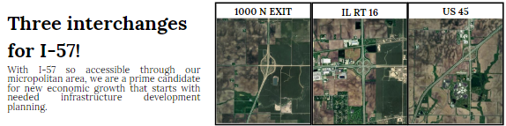

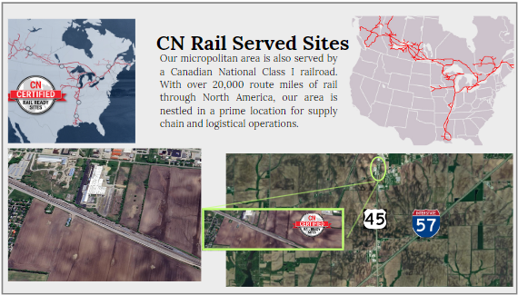

**Utility Infrastructure**

* Water & Sewer provided by municipalities with available capacity
* Natural Gas/Propane provided by Ameren Illinois, AmeriGas, Ferrell gas
* Electricity provided by Ameren Illinois and Coles-Moultrie Electrical Coop
* High-Speed Fiber provided by Consolidated Communications, Inc.

**Educational and Workforce Training and Resources are considerable in Coles County.**

According to Intersect Illinois, the population within a 60-mile radius of Coles County is a healthy 848,199 overall residents with 46,185 total population for Coles County. Multiple universities (EIU and U of I) and community colleges (Lakeland, Richland, Kaskaskia, Danville, and Parkland Community Colleges) provide a steady stream of college students of all age categories who are advancing their educational, technical, and vocational skills for current and future job opportunities in the East Central Illinois Region. Coles County alone contains the following educational partners, workforce resources, and business planning and funding providers:

* Eastern Illinois University
* Lakeland College
* SBDC
* WIOA

**Coles County Workforce by the Numbers**

Coles County contains a higher younger workforce population with 5390 aged 10-19 years old, 8746 aged 20-29, 5806 aged 30-39, 5229 aged 40-49, 5456 aged 50-59, and 3190 aged 60-64 with a median age of 37.1 years old. Over the past several years, the population has fluctuated and has become more stable in the last three years, with the population consisting of 52% males and 48% females in the workforce. Due to the prevalence of educational opportunities and workforce training programs, Coles County has a more educated workforce than observed in other areas, with 45.63% of the population achieving an associate’s degree or higher and 93.48% having a high school degree or higher.

The most significant job counts by occupation in Coles County are as follows:

* 12.55% (3,079) Office and Administrative Support
* 11.32% (2777) Executive, Managers, and Administrators
* 10.37% (2543) Sales
* 8.82% (2163) Production Workers
* 8.3% (2035) Education, Training/Library

The workforce distribution of total employees in Coles County is 34% Blue Collar and 65% White Collar positions, with an overall total of 24 419 employees in the labor force currently. According to Intersect Illinois, Coles County has 1659 active businesses. In 2023, the leading industries in Coles County were Education (4015 jobs), Manufacturing (3691 jobs), Healthcare (3070 jobs) and Retail (2713 jobs). With many sustainable, higher-paying positions, households in Coles County earn a median yearly income of $63,049. Specifically, 29% of the households earn more than the national average. In terms of housing, 60.2% are homeowners, with 39.8% renting, indicating that 20% more households own their homes than rent in Coles County. As seen in many other areas of the country, Coles County needs more housing options at all income levels to meet the community's current and future workforce growth needs.

According to Intersect Illinois, Unemployment is 4.8%, with a total workforce of 26,378 in Coles County alone. Compared to the U.S. National unemployment rate of 4.2%, Coles County unemployment is slightly higher than the national average. The Illinois Office of Employment Security Illinois unemployment rate was 5.2% in July 2024, so local and state unemployment rates trend slightly higher than the national average. This factor and a strong youth trend in the Coles County population indicate that some excess capacity in the labor market exists for additional job growth now and in the future.

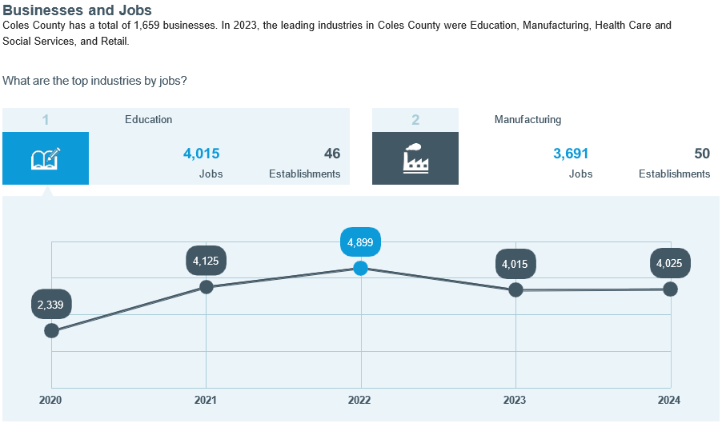

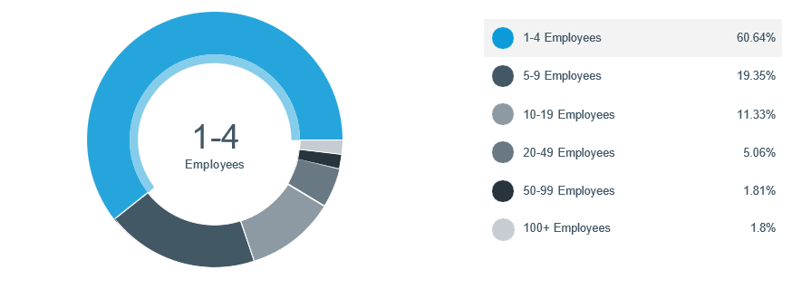

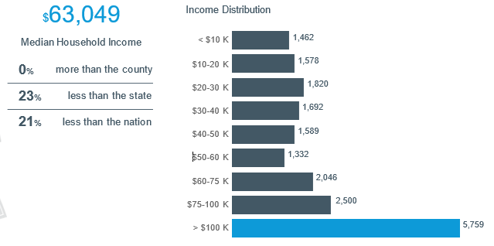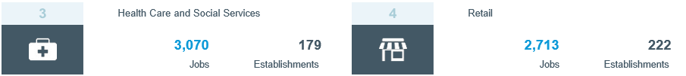

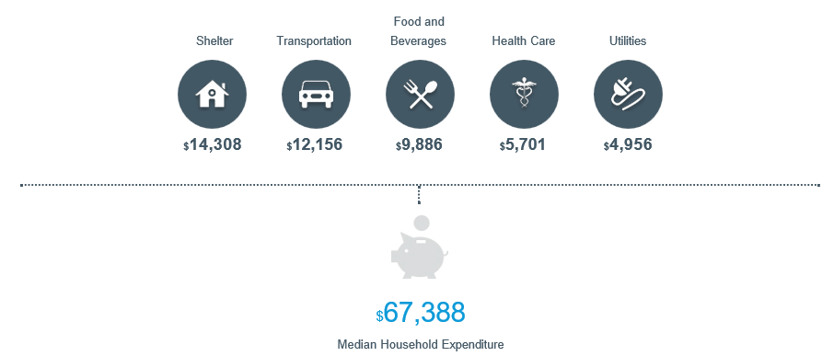

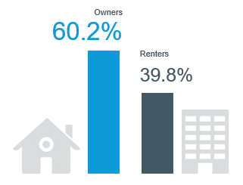

**Funding**

Coles Together continues to evaluate funding, grants, bonding, and other financial options needed to advance business retention and expansion and new business recruitment to Coles County.

**Conclusion and Next Steps**

Coles Together looks forward to working with all who want to advance economic development in Coles County, Illinois. This will be done through strong strategic planning, establishing key regional priorities and timelines for progress, proactively addressing key regional issues, legislative advocacy, outreach to key development professionals & building long-term relationships, developing networking development teams to get the work done, and overall working together! Intersect Illinois now recognizes Coles Together as a regional EDO and has issued EDO database capabilities to list the park properties for site selectors/brokers and gather the needed information. The new database capabilities will provide competitive information for Coles County to be seen as a strong regional force for economic development activities.

**“Unifying Voices, Together We Will Shape the Future!”**